CAST IRON CHARLIE

Questions for Dad
Facts only the family can confirm — for the documentary and family archive
For: Charles Mitchel Sorensen
Prepared by: Chris Sorensen — March 2026

18 questions across 4 sections. Each has space for your answer. Where relevant, the photograph in question is shown alongside it. No answer is too short — “I don’t know” is useful too.

1 — Facts to Confirm
Quick questions where sources disagree or where only the family record can settle it. These can be confirmed with a document or a single answer.

Q1 Charles Emil’s death date: Find a Grave says August 11, 1968; Wikipedia says August 28. Which is correct? A death certificate or newspaper obituary would confirm it.  ▶ Why it matters: The film cannot get this wrong. | Dad’s answer:

Q2 RESOLVED — The generational line is confirmed. Two questions remain about people in it. First: what do you know about Clifford M. Sorensen — Charles Emil’s only son, who died in Miami in 1967, a year before his father? He is almost entirely absent from the historical record. Second: did you know that Charles Emil remarried in 1960, after Helen’s death? His second wife was Edith Thompson Montgomery. She doesn’t appear in the family genealogy. Do you know anything about her?  ▶ Why it matters: Clifford is a biographical blank — family memory is the only source. And Edith Thompson Montgomery is a discovery not previously known to this project. Both are worth understanding. | Dad’s answer:

Q3 RESOLVED — Helen’s full name is confirmed as Helene E. Mitchell, born 5 March 1880, died 4 March 1959 in Miami, Florida. She predeceased Charles Emil by nine years. Do you know anything about her background — where she was from, how they met, what she was like?  ▶ Why it matters: Two yachts were named for her. The Helene II launch photographs show her at the christening. And she died a year before the day she was born, aged 78. Her story is part of the film and the family. | Dad’s answer:

Q4 Do you know the addresses of any of Charles Emil’s homes — the Grosse Pointe estate, the St. Clair River summer place near Algonac, or the Miami Beach winter house? Any details or photographs of any of them?  ▶ Why it matters: None of the three property addresses have been confirmed in the archive. The Miami Beach house connects directly to the burial location. | Dad’s answer:

2 — Places Only the Family Would Know
These properties and holdings are documented in sources but their details — location, scale, what happened to them — exist only in family memory.

Q5 CESOR Farm — Charles Emil’s 2,000-acre personal farm in Michigan, named for himself (Charles Emil SORensen), where he tested the civilian Jeep prototype before joining Willys-Overland. Do you know where exactly in Michigan it was located? And what became of it?  ▶ Why it matters: The farm is confirmed in Michigan. The exact location and what happened to it are unknown. | Dad’s answer:

Q6 Cuba — Charles Emil held extensive land there, seized by the Castro government after the Revolution. Do you know anything about it? Where it was, what was on it, when it was acquired, when it was taken?  ▶ Why it matters: A striking detail: the man who built the Arsenal of Democracy had his land taken by Castro. Worth documenting fully if possible. | Dad’s answer:

Q7 The US Virgin Islands — mentioned in sources as a retirement location alongside Florida. Do you know anything about a property there?  ▶ Why it matters: No details confirmed anywhere. Could be a minor footnote or a significant undocumented asset. | Dad’s answer:

3 — Photographs
A handful of key images need provenance confirmed before the film can use them. Where the photograph is known, it’s shown here.

Q8 This portrait of Charles Emil — do you know where it came from, when it was taken, or what he’s holding in his hands?  ▶ Why it matters: The strongest individual portrait in the collection. Almost certainly a title-card image for the film. Provenance is needed before production can use it. | 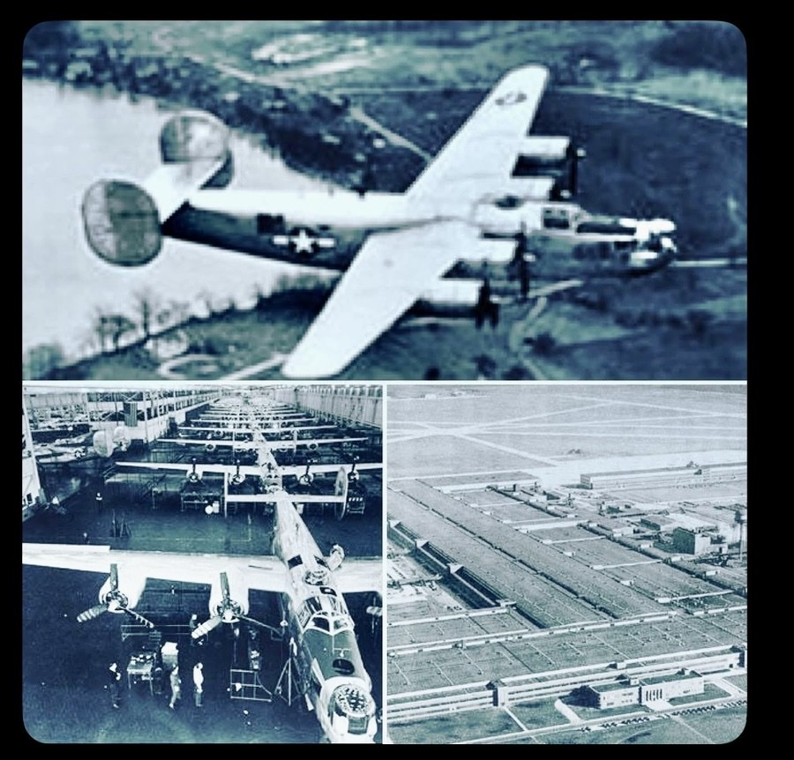  Charles Emil Sorensen — source unknown

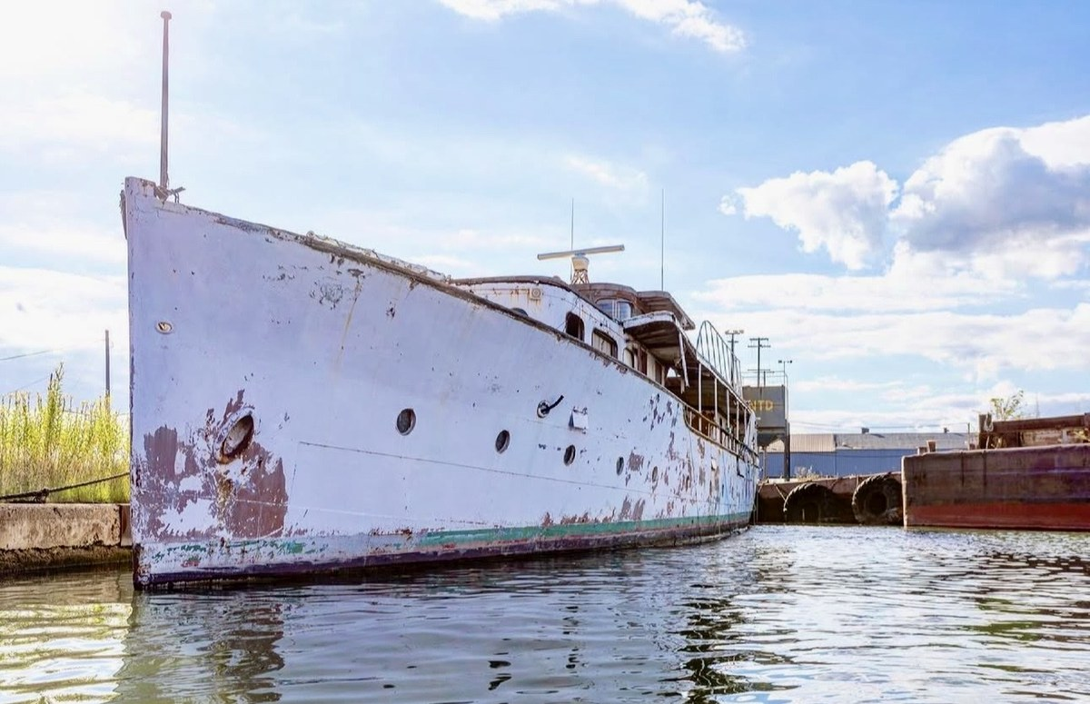  M/Y Helene I — port broadside, Nicholson Terminal | 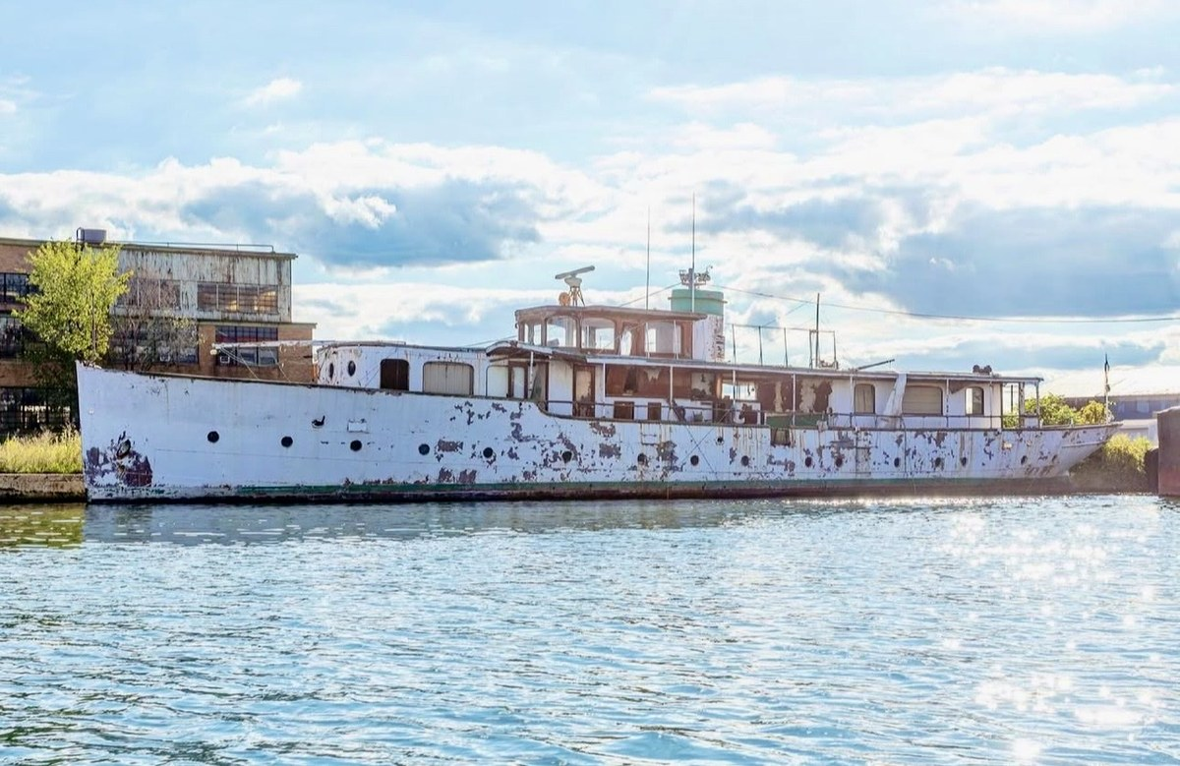  Bow-on — steel hull intact, open to weather

Q9 Who took these photographs of the first Helene at the Nicholson Terminal on the Detroit River? When were they taken? Separately — do you have any memory or family stories about what either Helene looked like inside? The Historical Collections of the Great Lakes at BGSU may hold several dozen interior photographs of the first Helene taken at launch in 1927 — rooms and details the family may never have seen.  ▶ Why it matters: Photograph rights need clearing for production use. And any family memory of the interiors would help contextualise what BGSU is about to share with us. | Dad’s answer:

Q10 This shows Sorensen (centre, civilian suit) with military personnel on an airfield, circa 1942. Do you know anything about this occasion or who the other figures are?  ▶ Why it matters: Any context would significantly increase the image’s value to the film. | 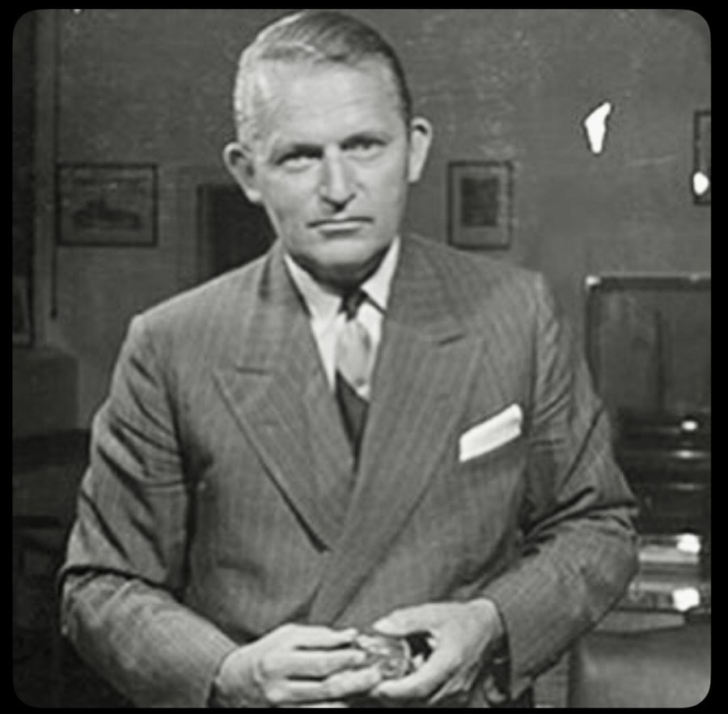  Sorensen with military personnel, c.1942 (Historic Images)

Q11 This is Roosevelt, Henry Ford, and Sorensen (centre-rear) touring Willow Run on September 18, 1942. Eleanor Roosevelt was also present. Is there any family memory or story connected to this day?  ▶ Why it matters: One of the most significant photographs in the public record of the war. Any family dimension — however small — would be valuable. | 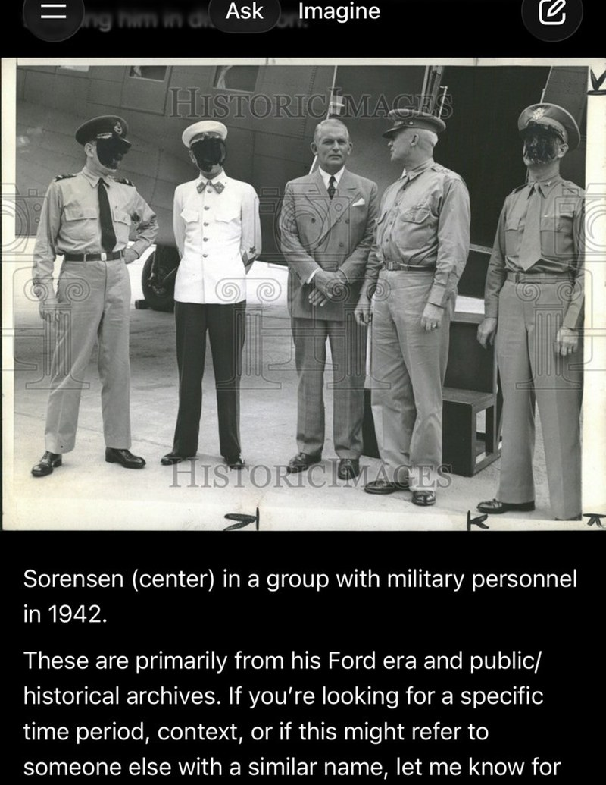  Roosevelt, Ford, Sorensen — Willow Run, Sept. 18, 1942 (U.S. Navy / The Henry Ford)

Q12 Are there any other photographs in the family’s possession that haven’t been shared yet — of Charles Emil at Ford or Willys, with family members, or at any of his homes?  ▶ Why it matters: The most open-ended visual question. The family archive may hold material no researcher has ever seen. | Dad’s answer:

4 — Personal and Family Memory
These are the questions no archive can answer. Take as long as you need with each one.

Q13 What was Charles Emil like as a man — as a grandfather, as a presence in the family? What do you know about him from your own father or others who knew him?
▶ Why it matters: The film needs a human portrait, not just an industrial one. Family memory is the only source for this.

Dad’s answer:

Q14 Was Charles Emil’s relationship with Henry Ford ever discussed in the family? The full picture is complicated: Sorensen championed Henry Ford II’s rise, sided with Edsel Ford against both the elder Henry and his enforcer Harry Bennett, and lost his position partly as a result. Henry Ford II’s first act on taking control was to fire Bennett. Sorensen then received a generous retirement package. Did anyone in the family talk about Ford, about Edsel, or about the way it ended?
▶ Why it matters: Sorensen’s memoir is measured on the personal cost. Family memory may be more candid.

Dad’s answer:

Q15 Harry Bennett — Ford’s enforcer, a man with organised crime connections who broke into Edsel Ford’s own home and smashed his liquor stock while the family was away. Sorensen opposed Bennett throughout and blamed him for Edsel’s early death. Was Bennett ever mentioned in the family? Did Charles Emil ever speak about him?
▶ Why it matters: The memoir is damning but restrained. Private conversation may have been less so.

Dad’s answer:

Q16 Did Charles Emil ever speak within the family about the assembly line — about whether he or Henry Ford deserved the credit for inventing it? Did he feel history had been unjust to him?
▶ Why it matters: The central question of the entire film. Any family testimony on this is gold.

Dad’s answer:

Q17 Did the family ever have any contact with the Danish royal family beyond the two decoration ceremonies in 1930 and 1937? Did Charles Emil ever return to Denmark?
▶ Why it matters: The March 2026 letter to King Frederik X is framed as a renewal of a historic bond. Earlier connections would deepen that narrative.

Dad’s answer:

Q18 Is there anything about Charles Emil — a story, a saying, a habit, a decision, something he did or said — that has been passed down in the family and that you think the documentary absolutely must include?
▶ Why it matters: The most important question on this list. Whatever the answer is, it will be something no archive holds.

Dad’s answer:

Add any additional answers or memories directly to this document.
Cast Iron Charlie — Sorensen Family Documentary Project — March 2026

